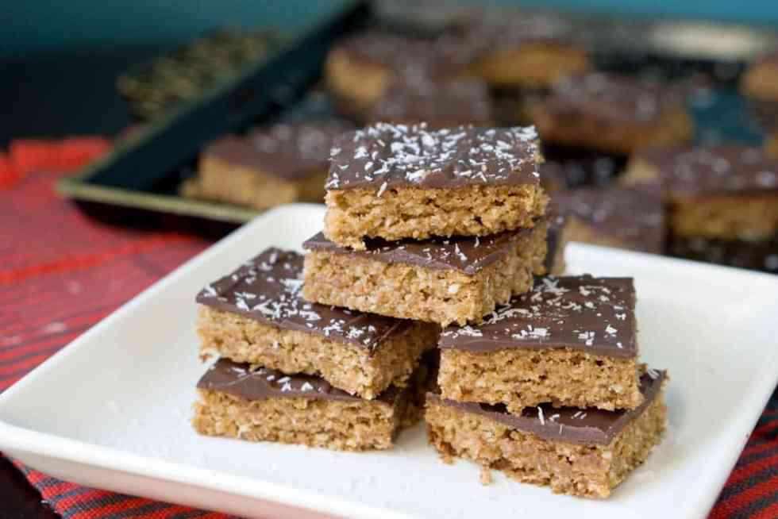
English Toffee Bars
Prep time 15 min Cook time 12 min
Approximately 5 dozen cookies
Ingredients
½ lb butter, melted (2 sticks)
1 cup brown sugar
2 cups flour
1 egg
1 tsp vanilla
1 (16 oz) bag chocolate chips
Chopped walnuts (or other desired topping)
Directions
- Preheat oven to 350 degrees.
- Mix butter, brown sugar, flour, egg and vanilla.
- Place batter on a lightly greased cookie sheet. Cover with wax paper. Use a small rolling pin or hand press to spread evenly.
- Bake 10-12 minutes, rotating pan 180 degrees halfway through cooking time.
- Remove from oven and sprinkle chocolate chips on top. When partially melted, spread with spatula.
- Sprinkle nuts or other desired topping on top.
- Let chocolate harden before cutting into small squares. (Cookies can be put in the refrigerator to speed up cooling process.)

